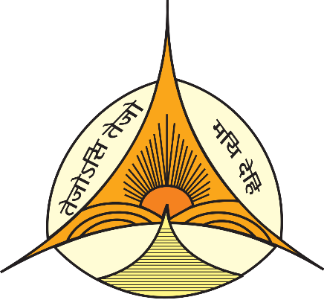

DETAILS OF EVENTS ORGANIZED BY THE DEPARTMENT OF ENGLISH, JESUS AND MARY COLLEGE, UNIVERSITY OF DELHI

ACADEMIC YEARS:
2020-2021
2021-2022

DEPARTMENT OF ENGLISH EVENTS 2020-2021

Impact of the Pandemic on the Metropolitan Middle-Class Indian Woman, Webinar Organized by IQAC in Collaboration with the Department of English, 12th June 2020
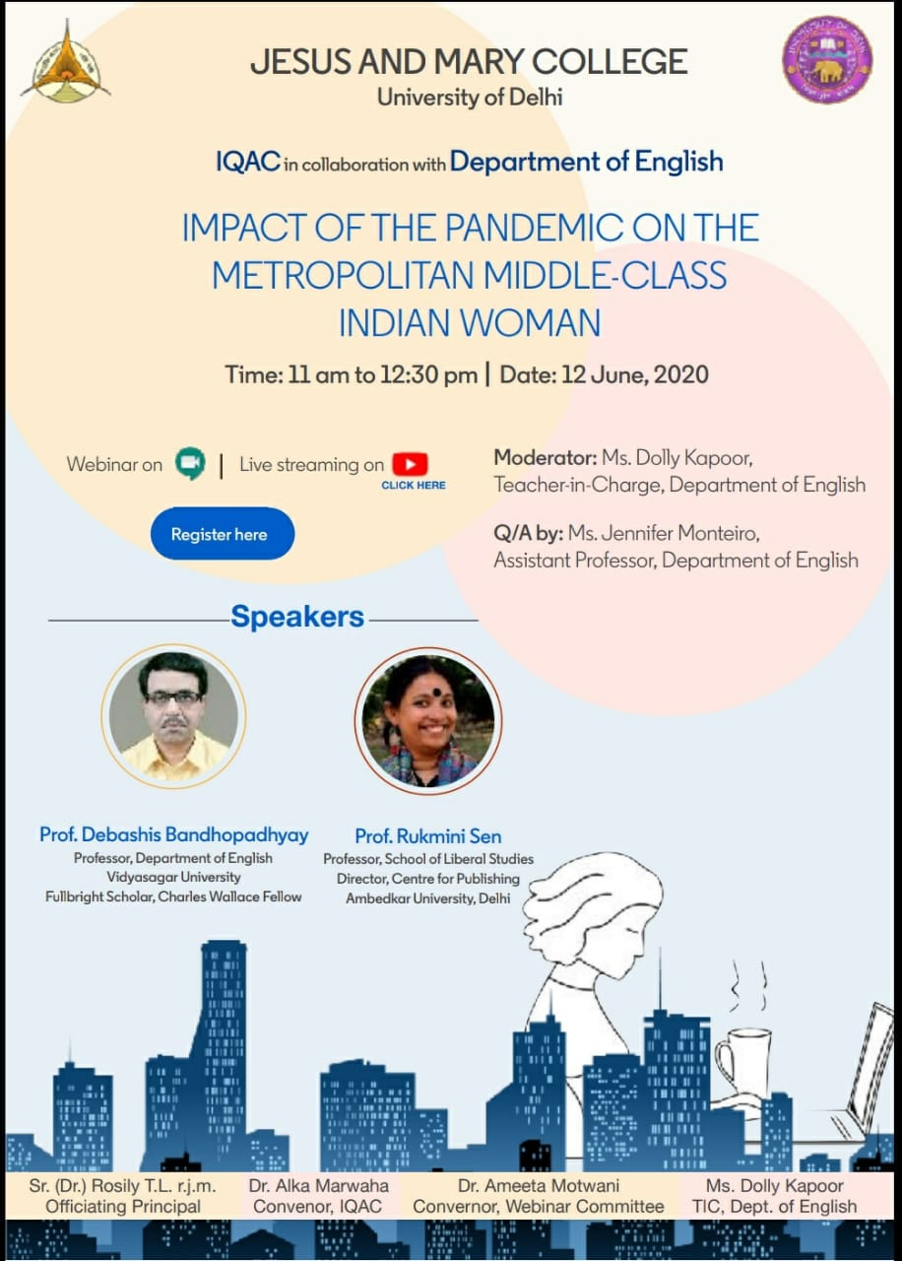

Stigma and the Covid Pandemic: Testimonies of Resilience, Resistance and Agency, Webinar Organized by IQAC in Collaboration with the Department of English, 25th June 2020

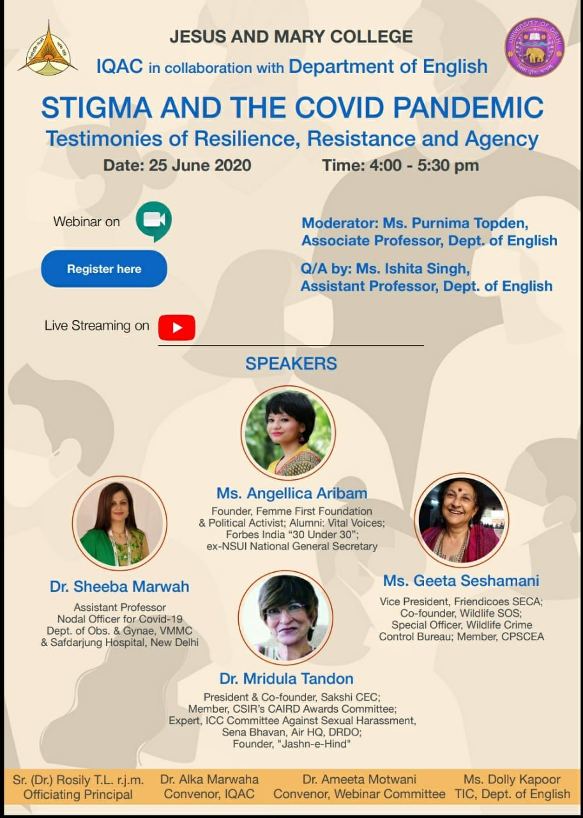
#Inktober 2020 (Instagram, October 2020)
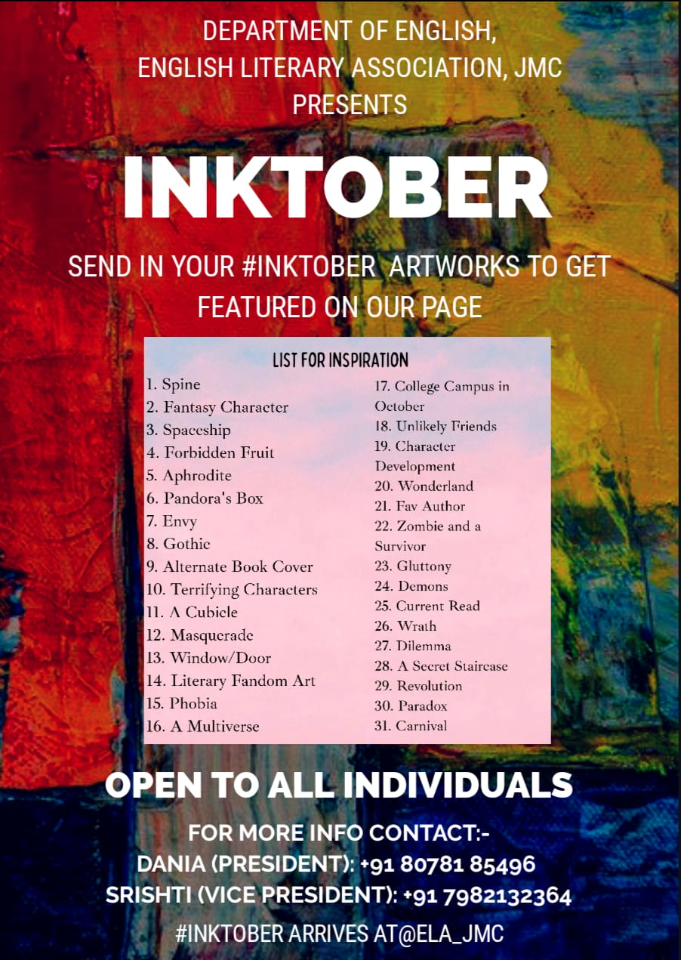
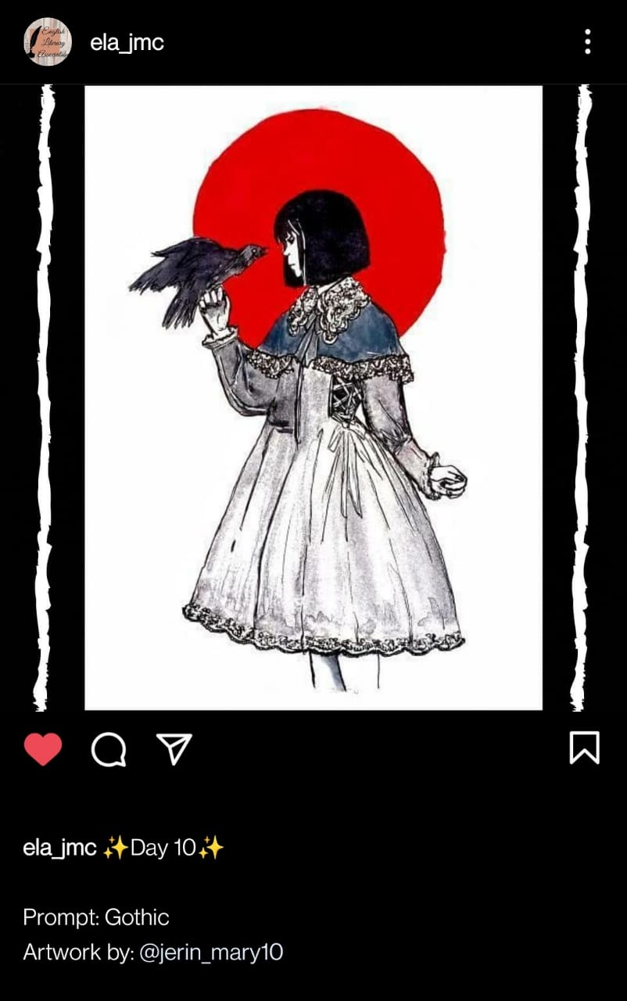

The Anupama Nair Creative Writing Competition 2020 (4th November, 2020)
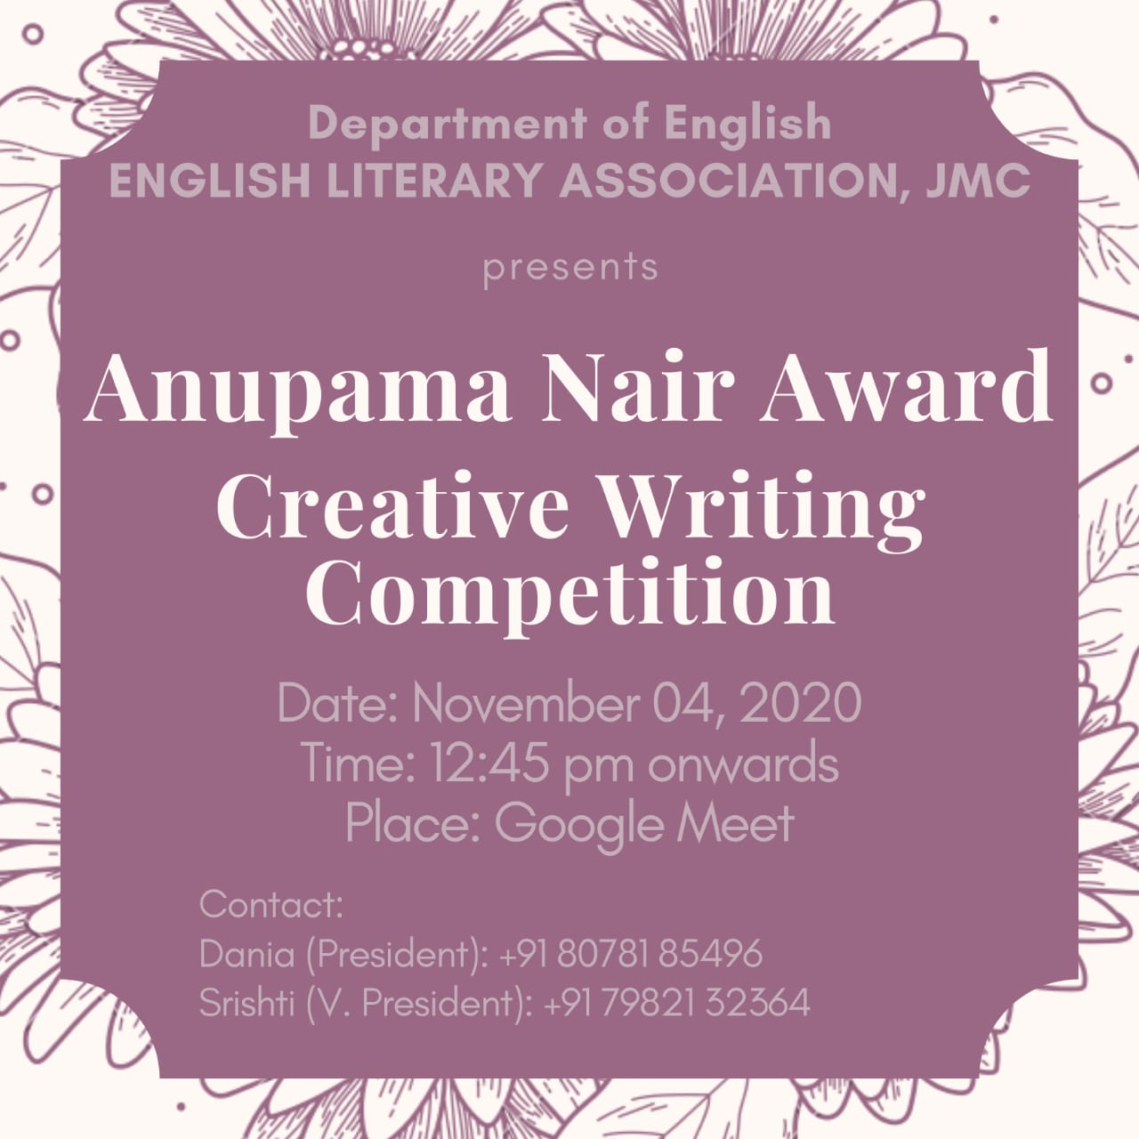

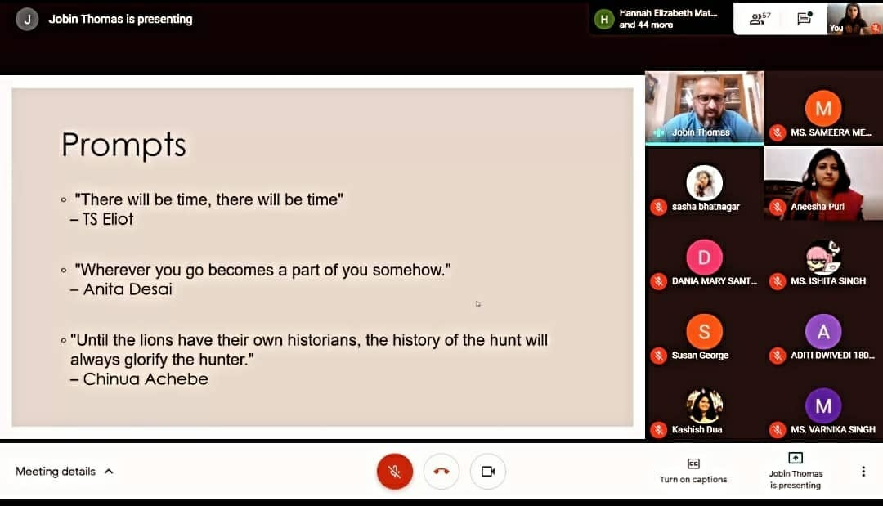

LitScroll, the Department Magazine, Published its Volume 1 (December, 2020)
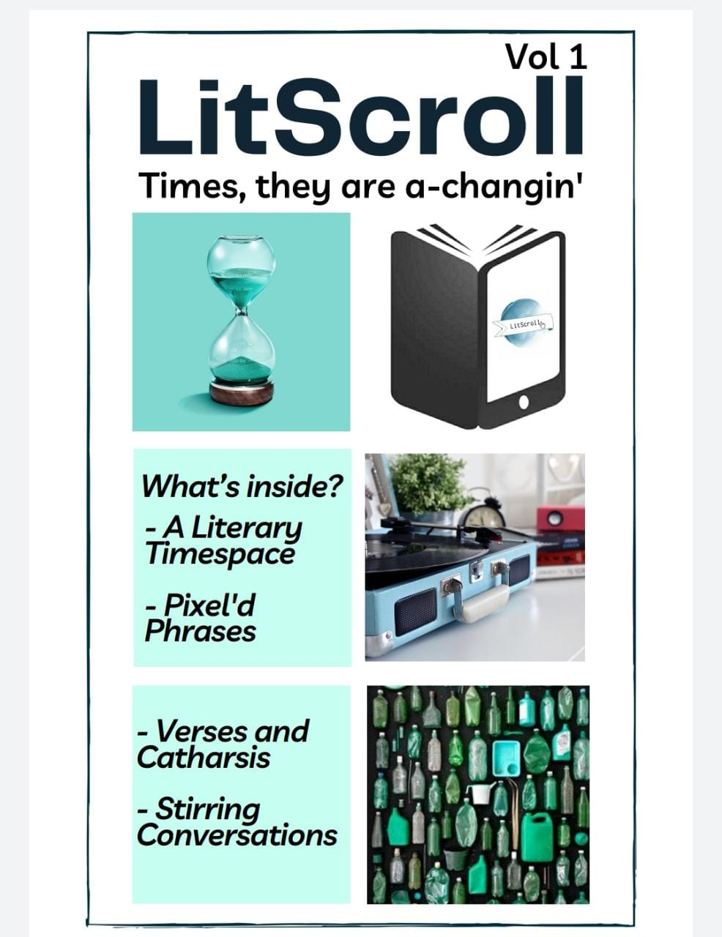

Fresher’s Welcome 2020-2021 based on the theme “Comfort of your Home” (Trouvaille, 7th January 2021)
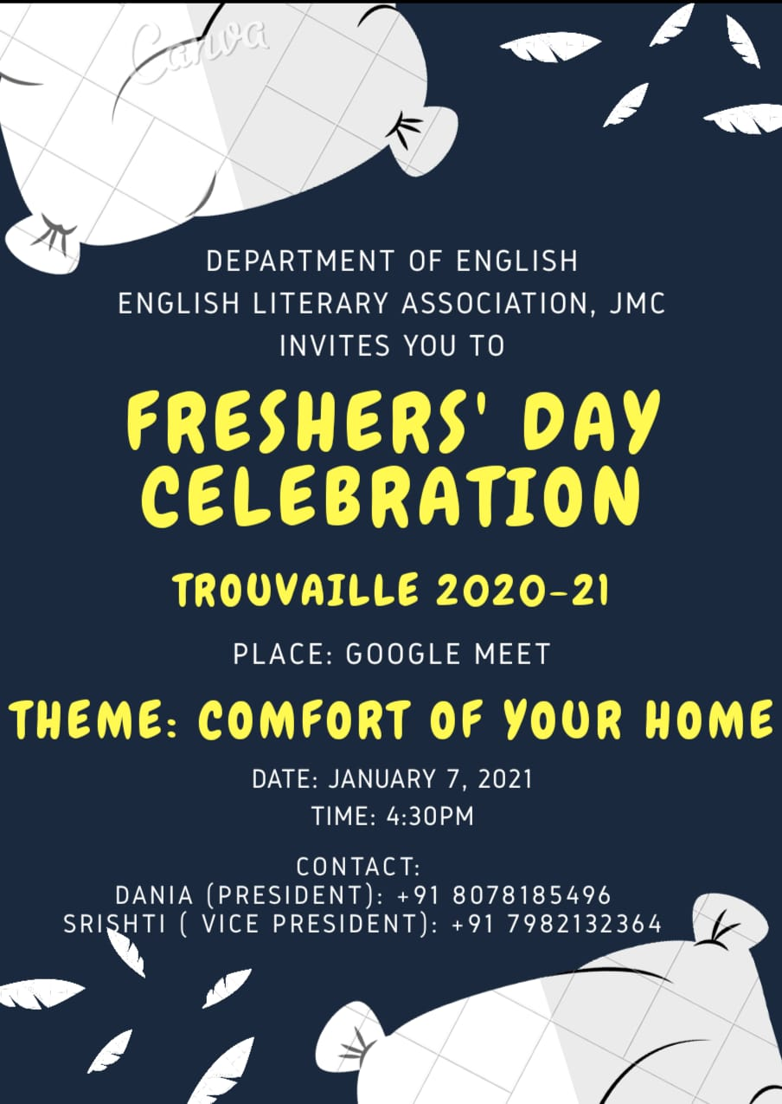

Fresher’s Welcome 2020-2021 based on the theme “Comfort of your Home” (Trouvaille, 7th January 2021)
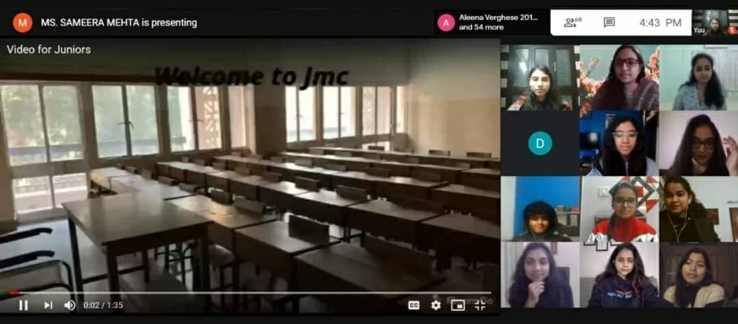

Career Day with Alumnae, Speakers: Ms. Parul Goel, Ms. Shilpa Sunny, Ms. Atulya Lucy Alexander (10th February 2021)
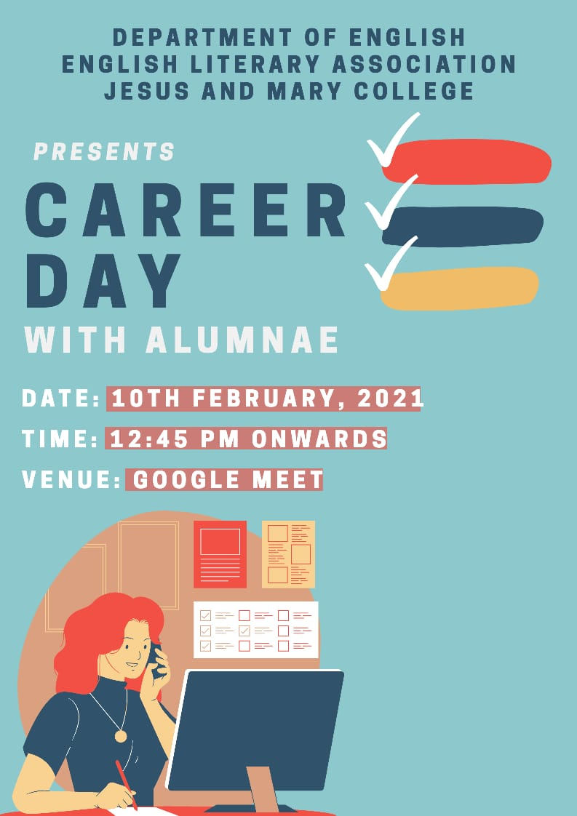

#Litterateur, Book Recommendations by the Students of the English Department (Instagram, March 2021)
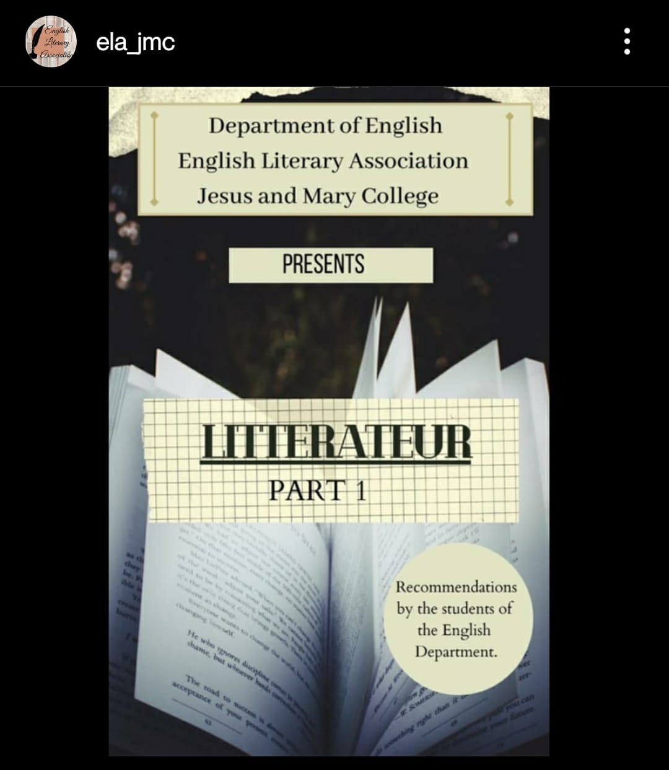
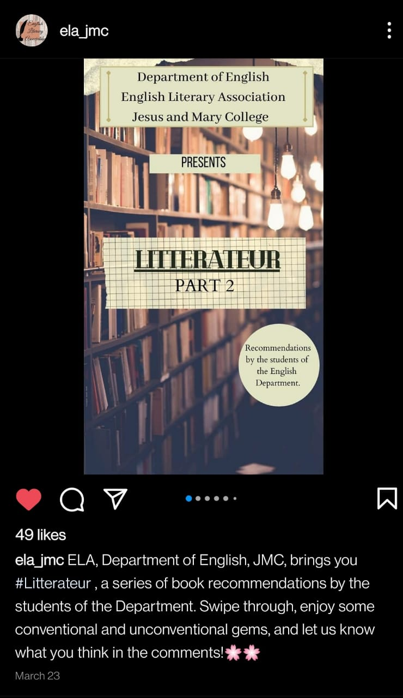
‘LECTURE SERIES’
Modernity and Society (7th April, 2021)
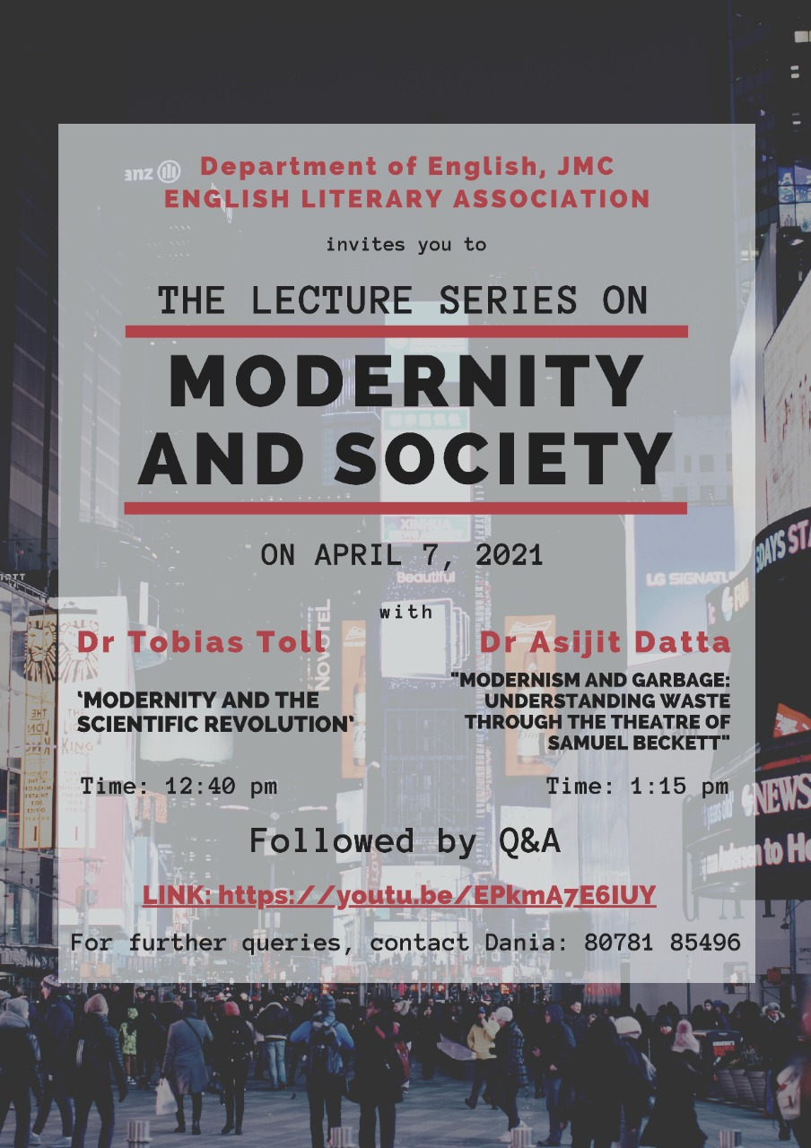
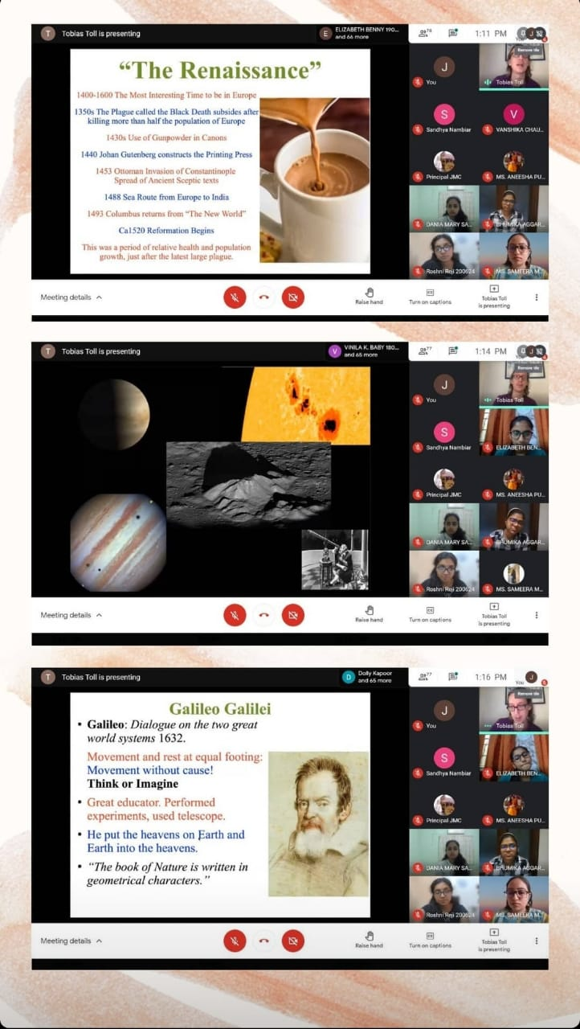
‘LECTURE SERIES’
Contemporary in Culture (8th April, 2021)
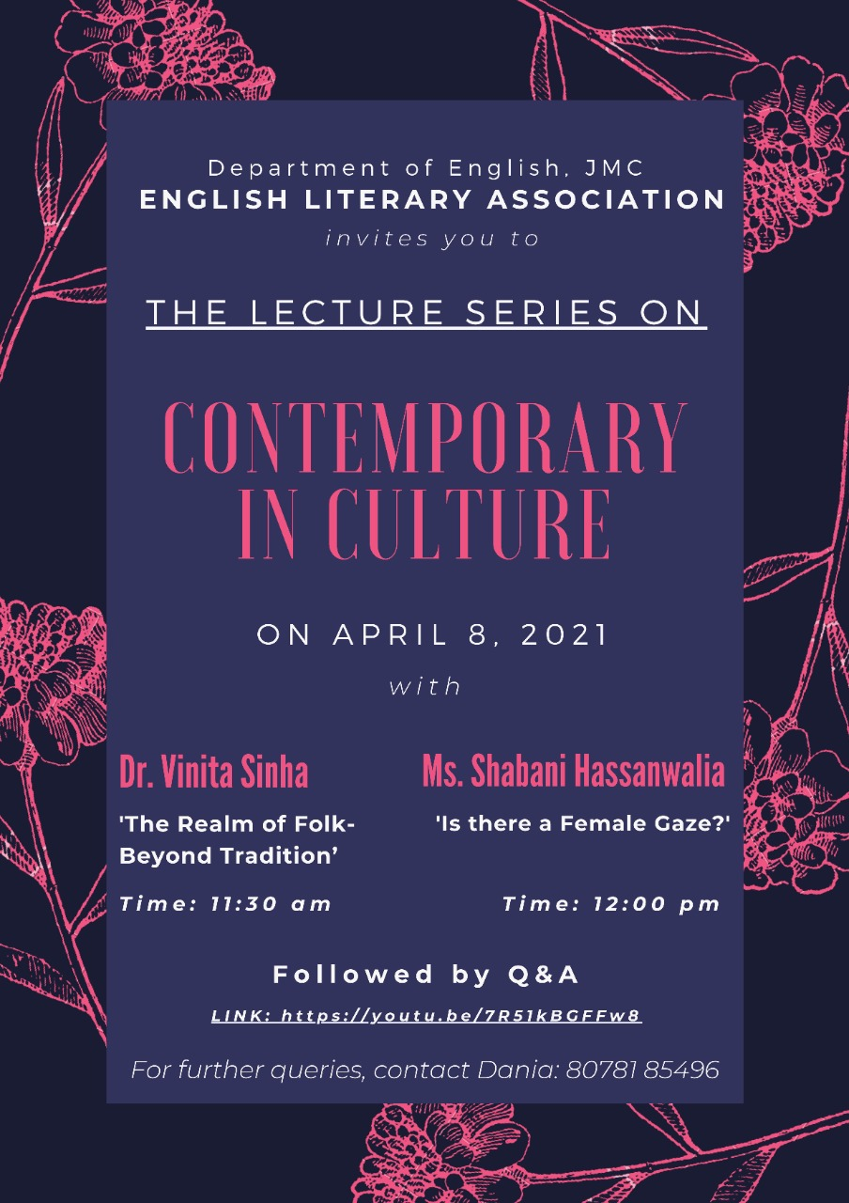
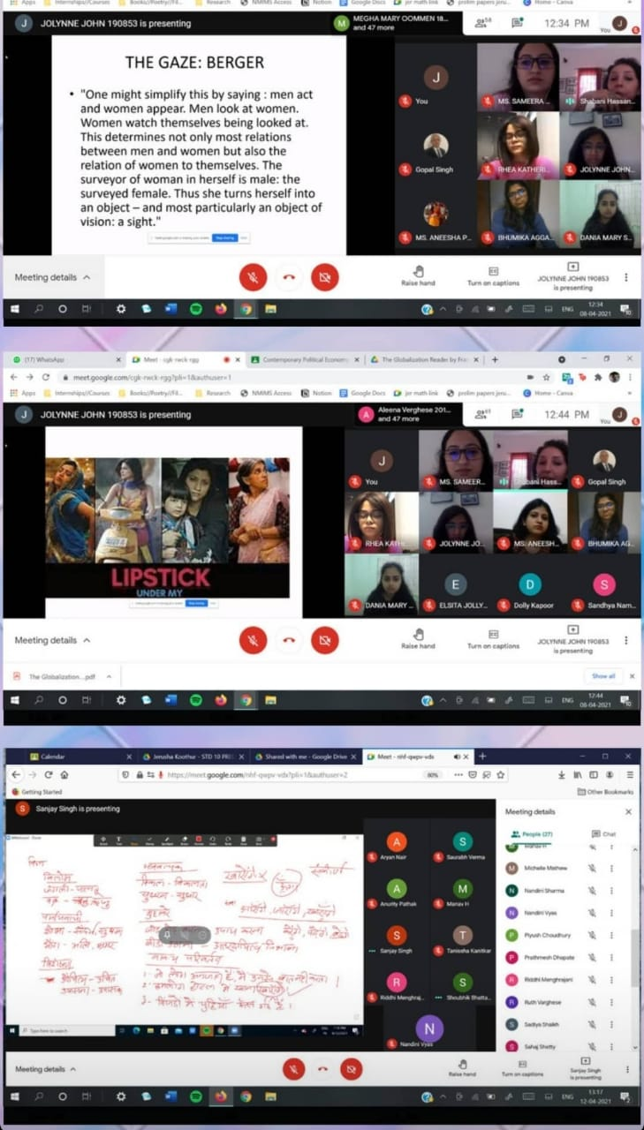
Cauldron X LitScroll Panel Discussion on Publishing (21st April, 2021)
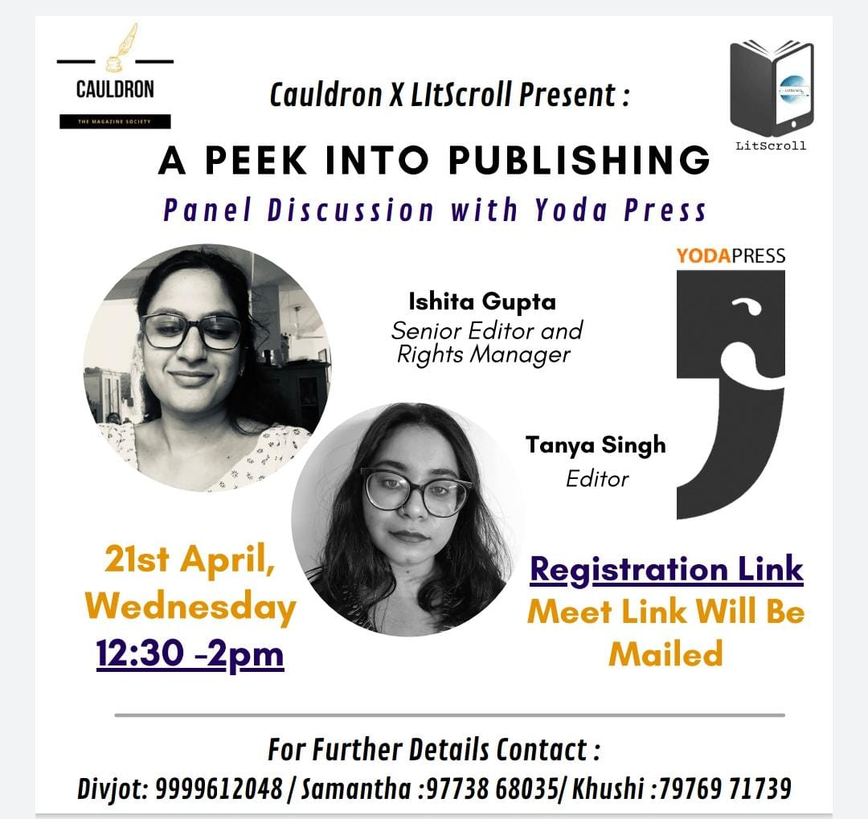

Introductory Lecture by Ms. Harriet Raghunathan for the First Years on Chaucer’s Canterbury Tales (23rd April, 2021)
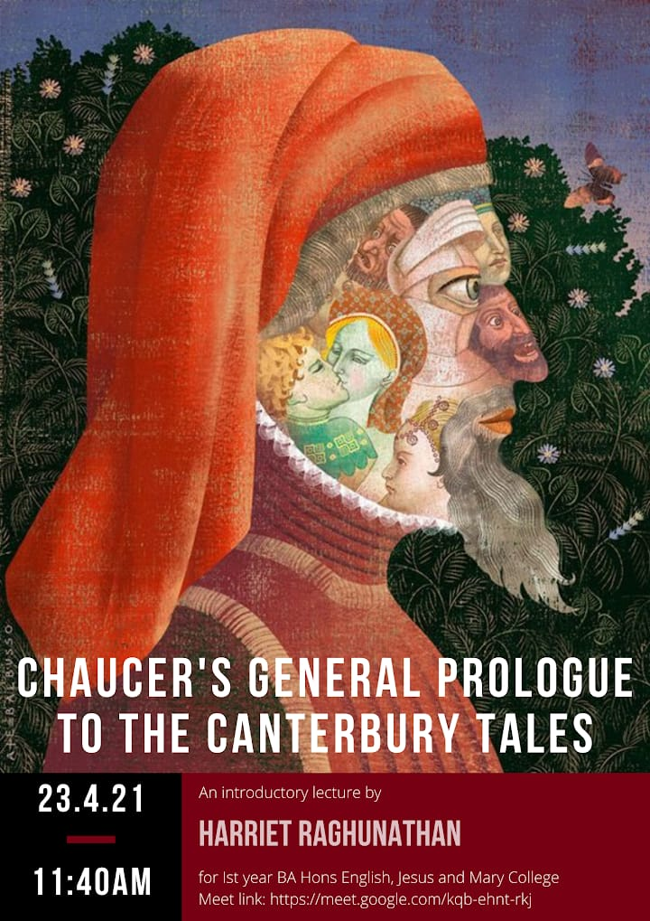
Farewell 2021 (Sayonara Senpai, 22nd June 2021)
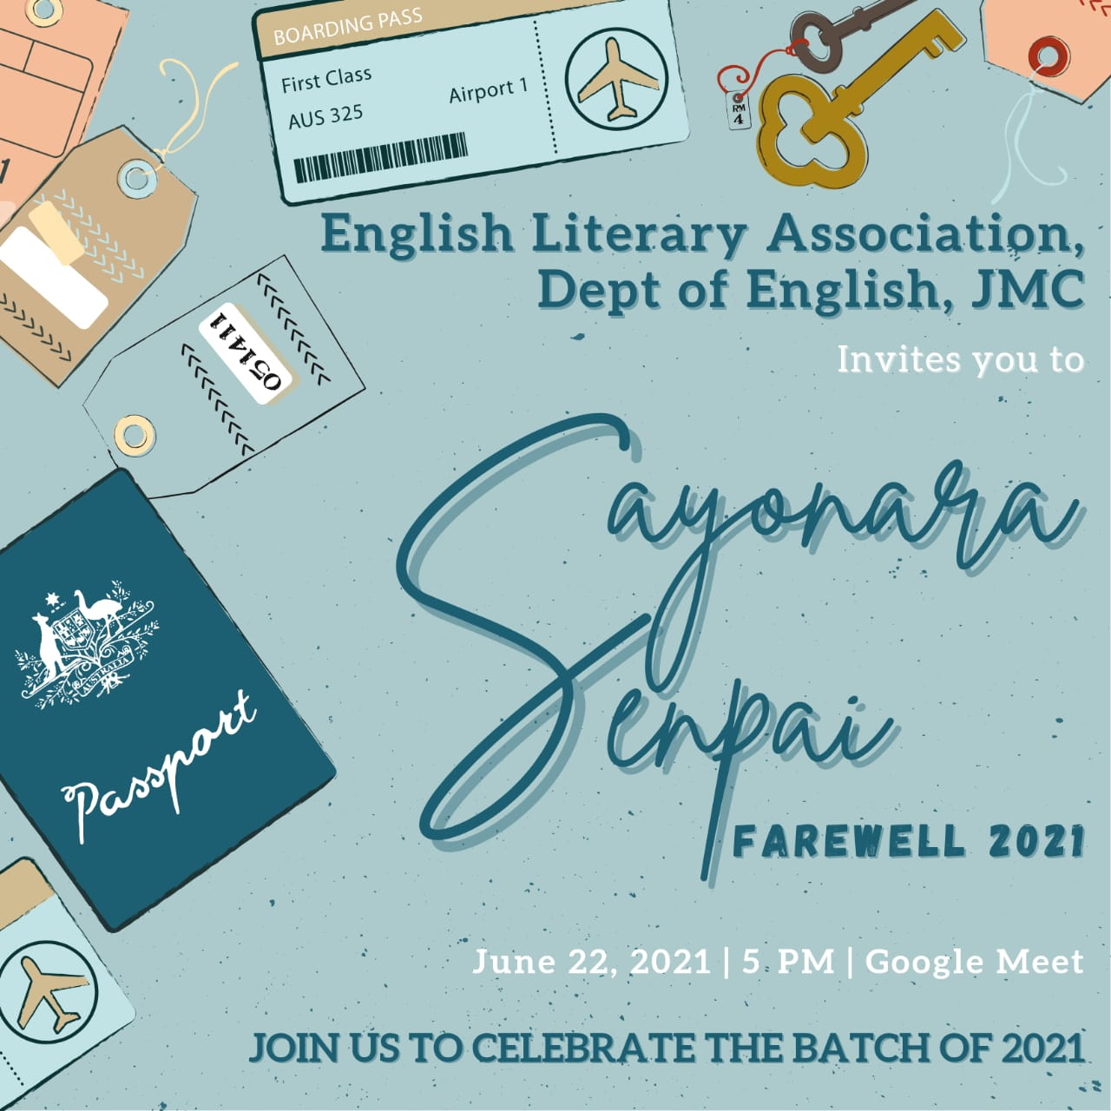
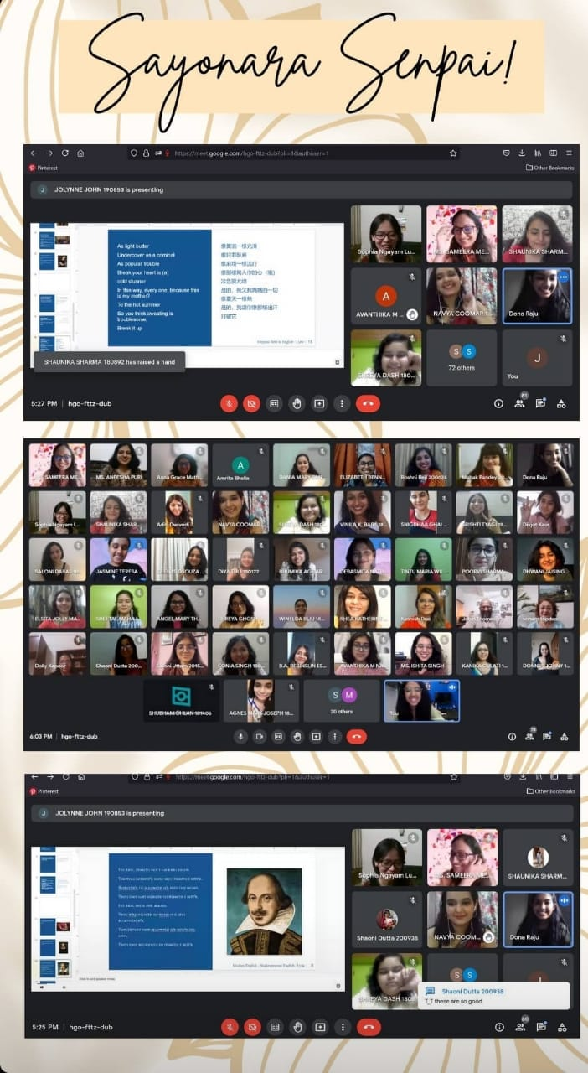
DEPARTMENT OF ENGLISH EVENTS 2021-2022

Department of English, JMC in Collaboration with Prakriti Foundation, “Poetry-Reading Session with Dr. Monica Mody” (18th September 2021) (Zoom)
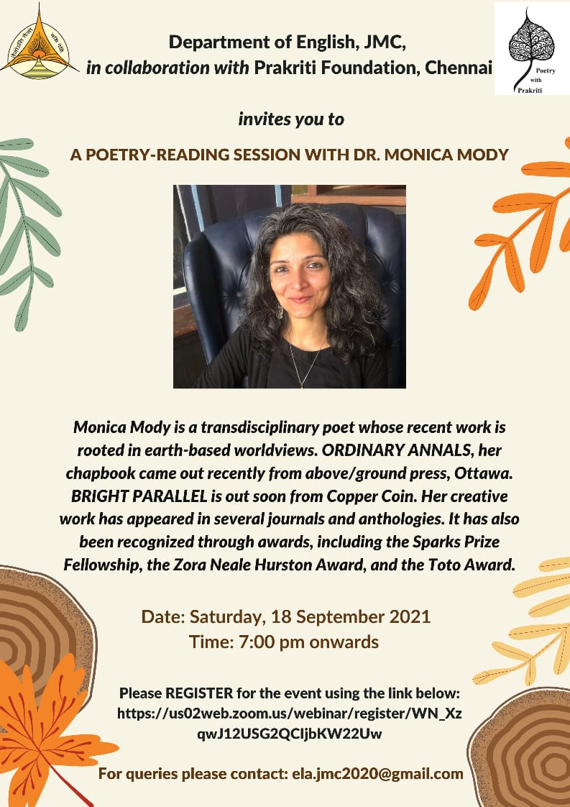

Department of English, JMC in Collaboration with Prakriti Foundation, “Poetry-Reading Session with Annie Zaidi” (9th October 2021) (Zoom)
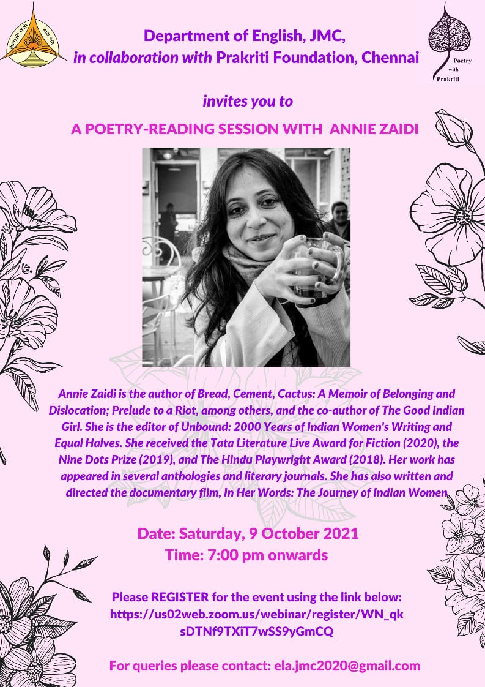
Department of English, JMC in Collaboration with Prakriti Foundation, “Drama. Discourse. Dialogue. A Retrospective of Plays with Manjula Padmanabhan” (30th October 2021) (Zoom)
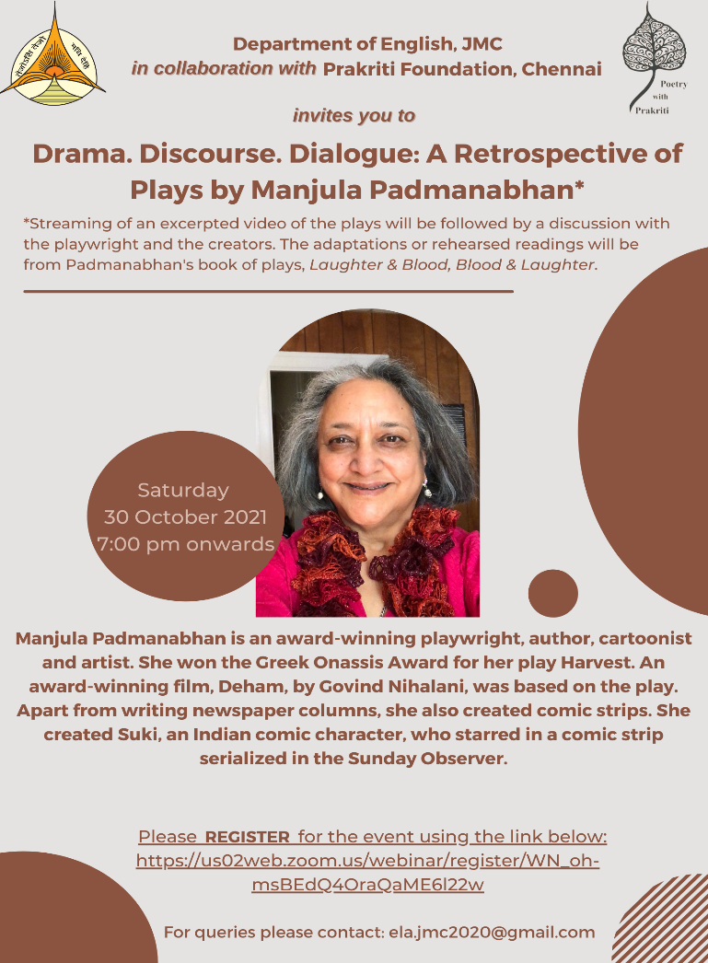

NAAC Department Board Decoration on the theme “Through the Lens of Gender” (27th October – 1st November)
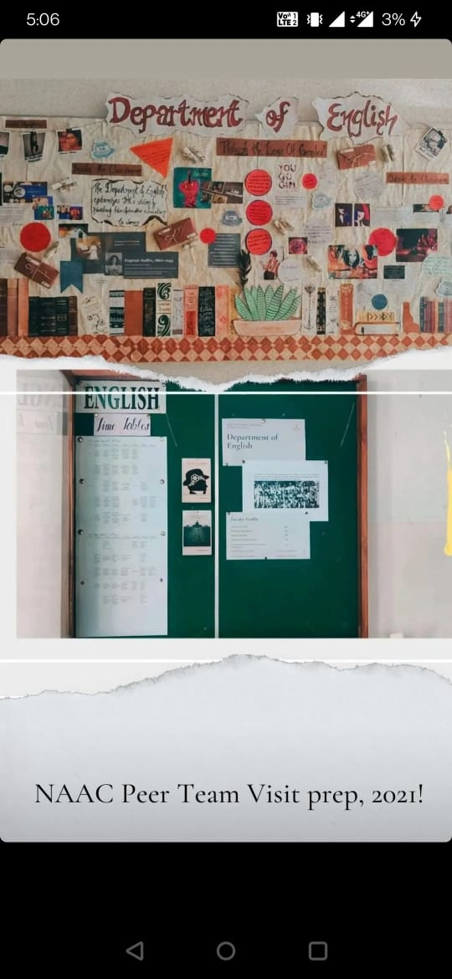
Fresher’s Welcome 2021-2022, Trouvaille, based on the theme: ‘Bring Your Own Aesthetic’ (12th January 2022) (Google Meet)
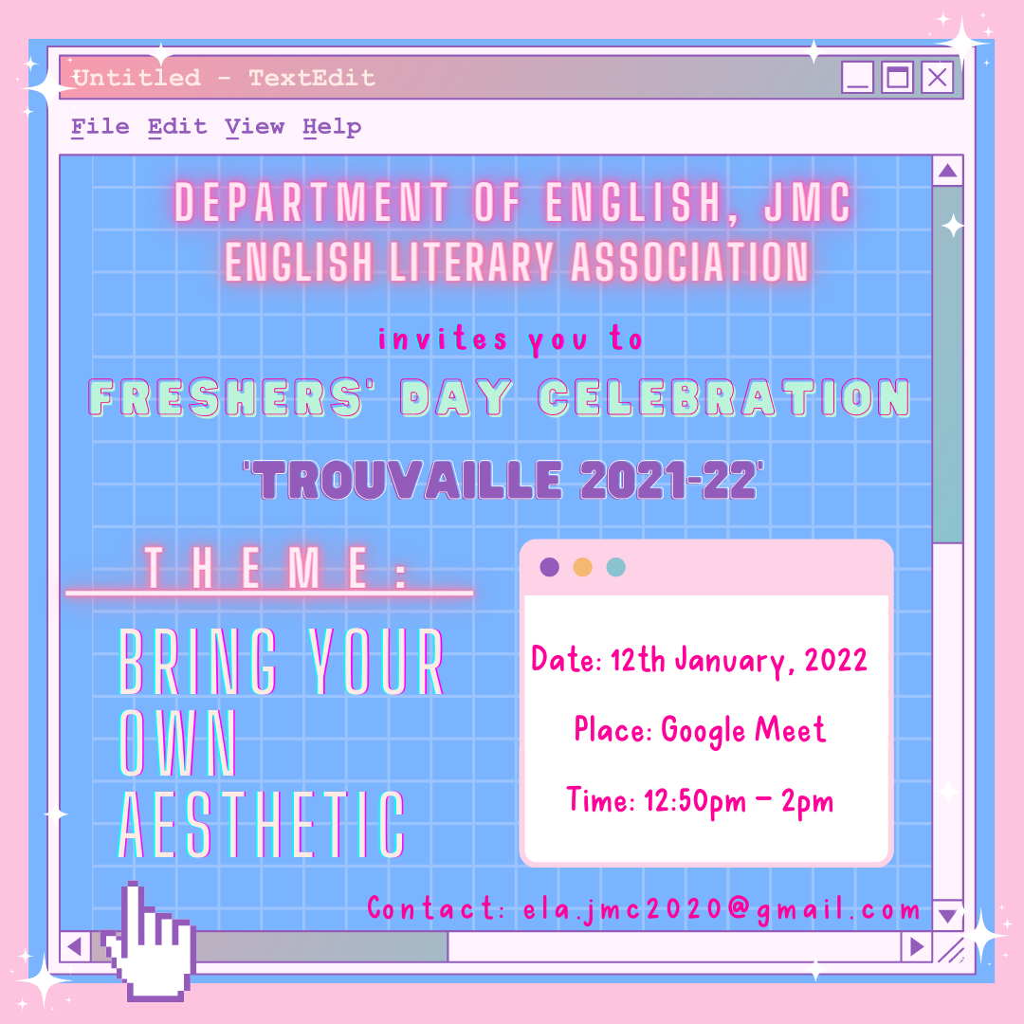
Anupama Nair Award Creative Writing Competition 2021-2022; Result Ceremony (2nd February 2022) (Google Meet)
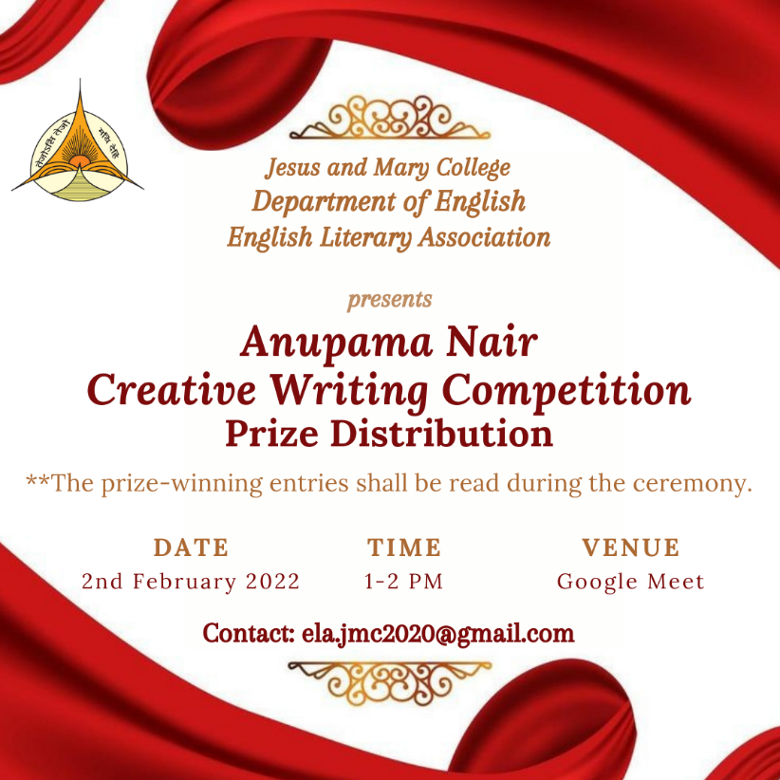
Career Day with Alumnae 2022; Speakers: Ms. Vagisha Joshi, Ms. Sanya Taneja and Ms. Suvidha Jani (16th February 2022)
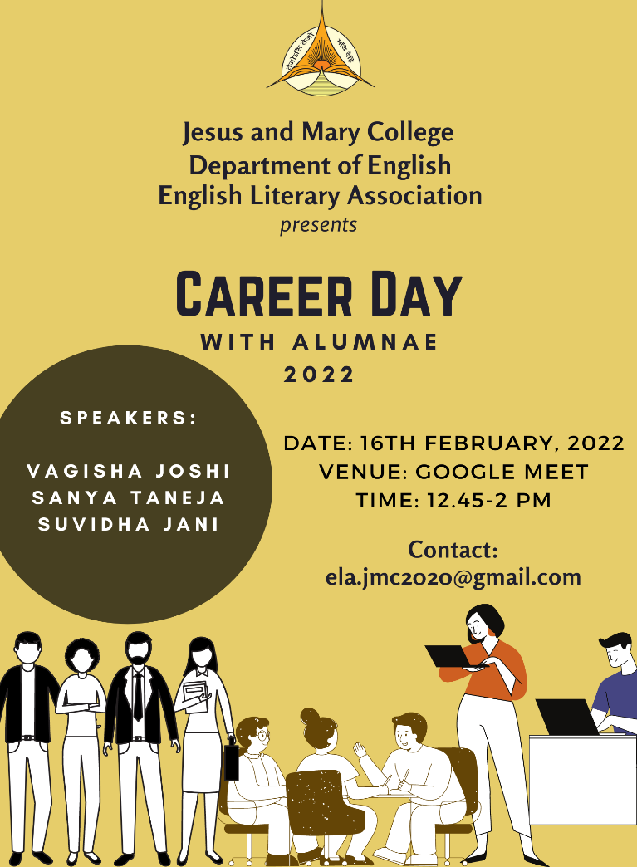

Department of English, JMC in Collaboration with Prakriti Foundation, “Poetry-Reading Session with The Quarantine Train”; Aswin Vijayan, Arjun Rajendran, and Anesce Dremen (26th February 2022) (Zoom)
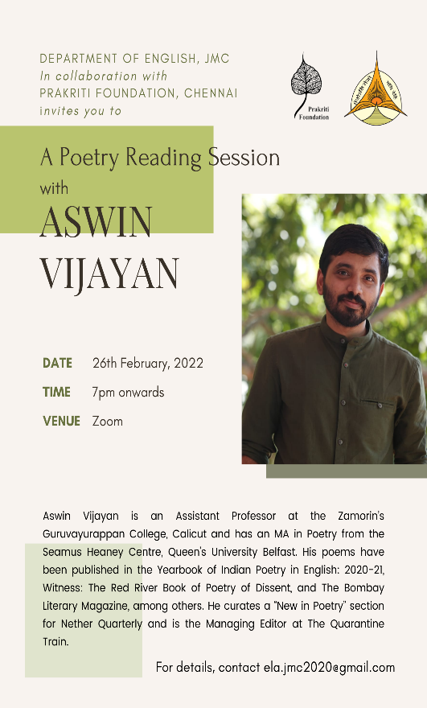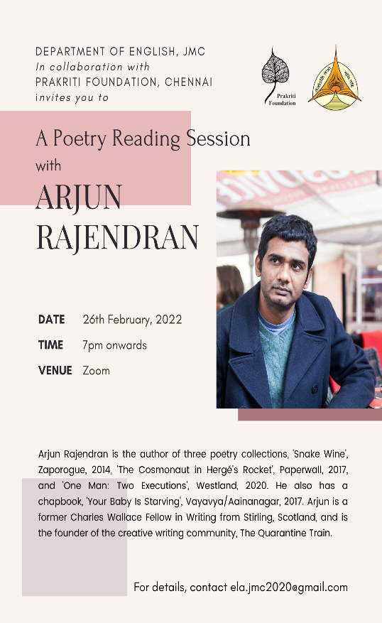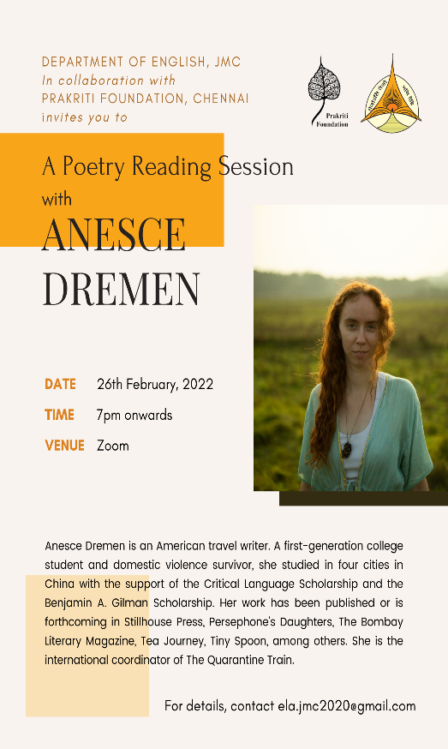

Meet The Author 2022 – Paul Waters (7th March 2022) (Google Meet)
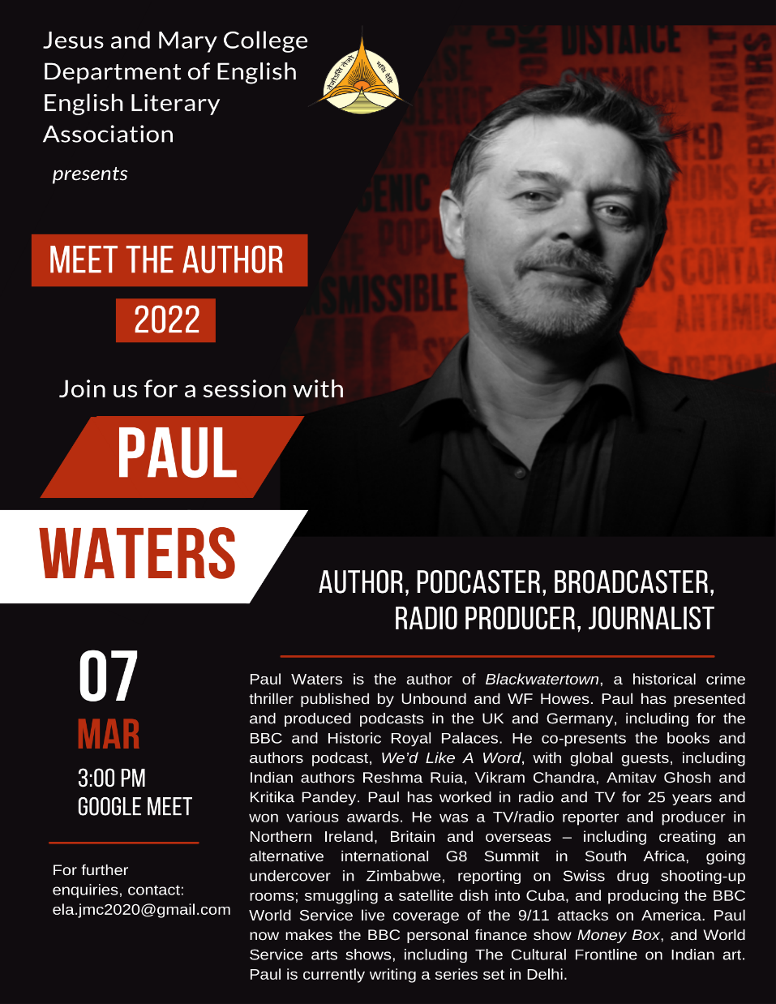
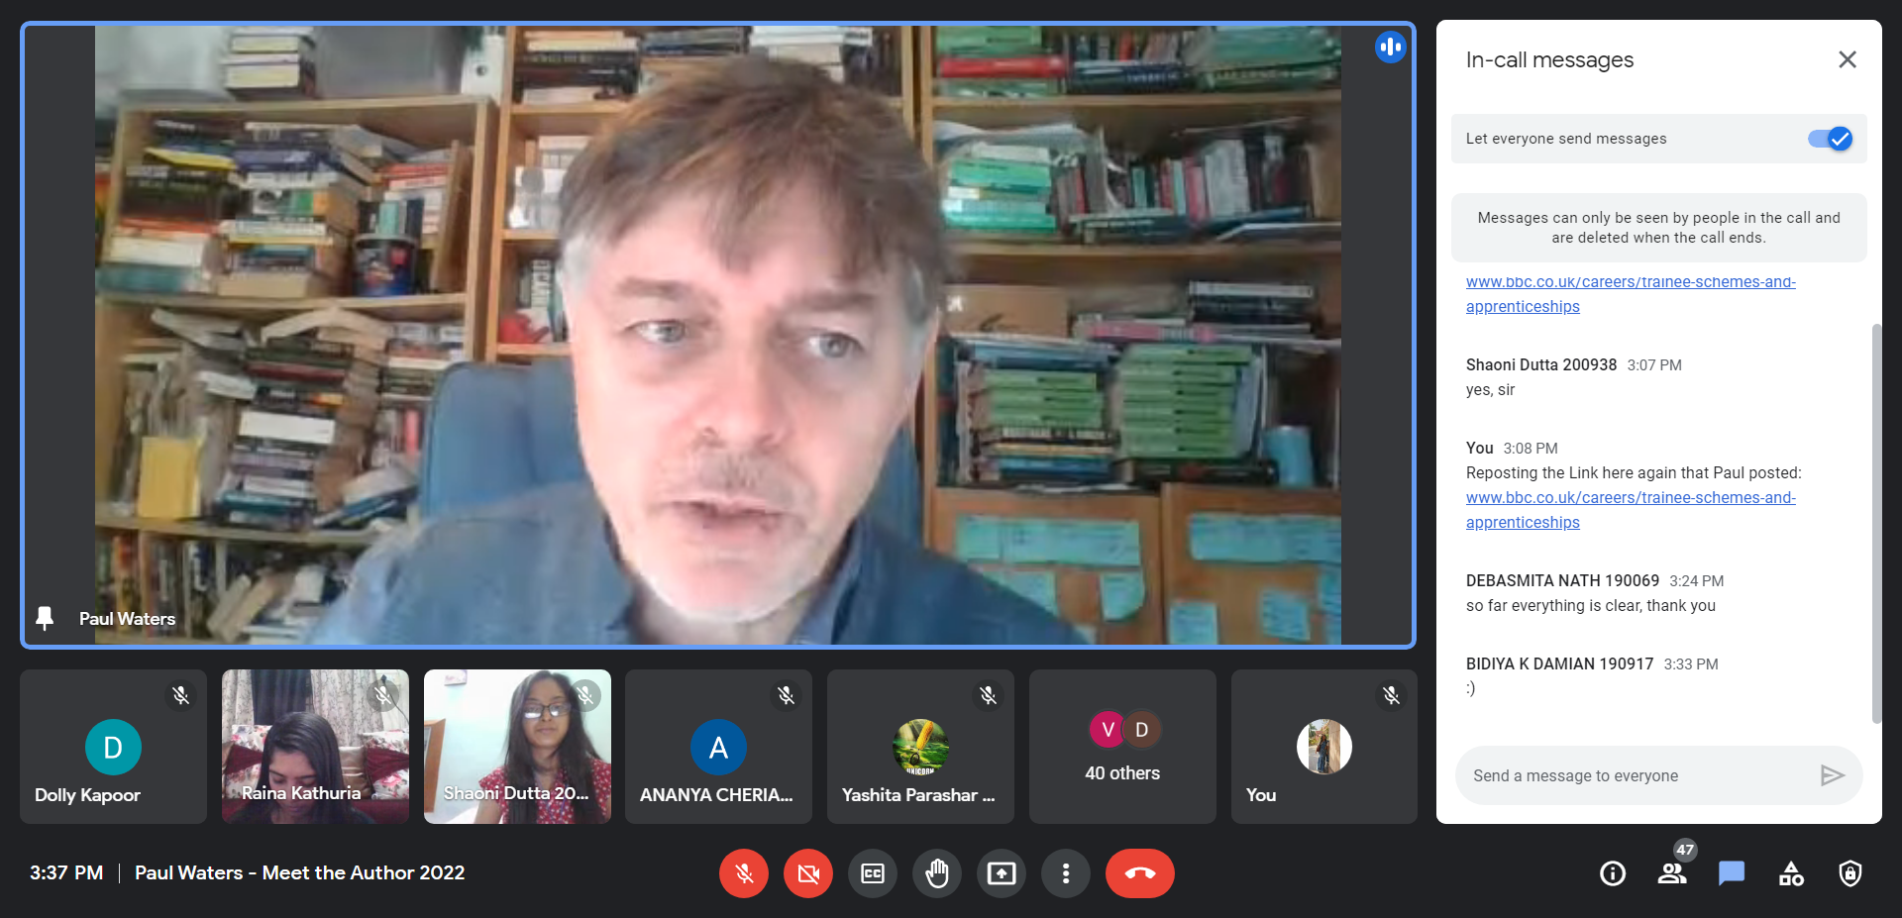
Sarnath Banerjee “Keynote Lecture” for Literati (7th April 2022) (Google Meet)
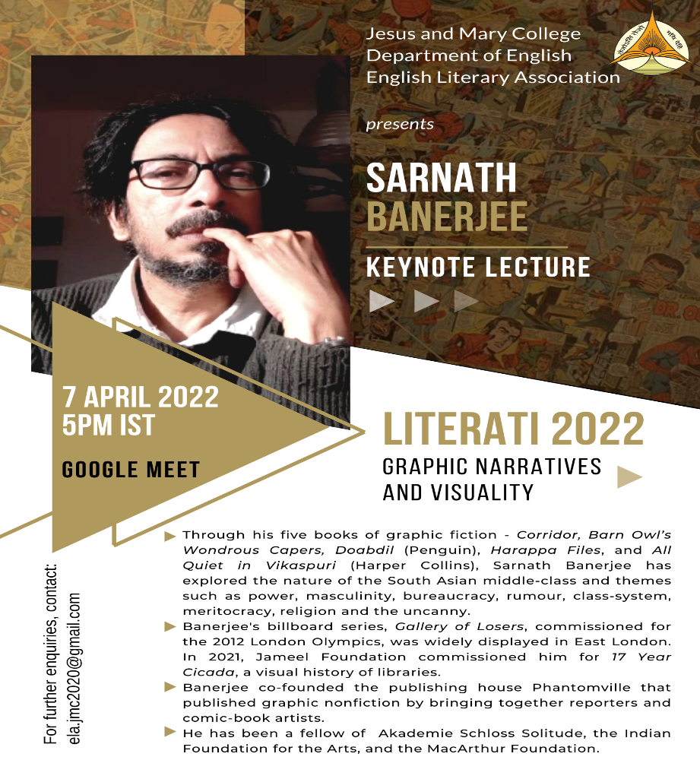

AP Payal Talk “Reading the Cards: Exploring the Feminist Possibilities of the Tarot” (13th April 2022)
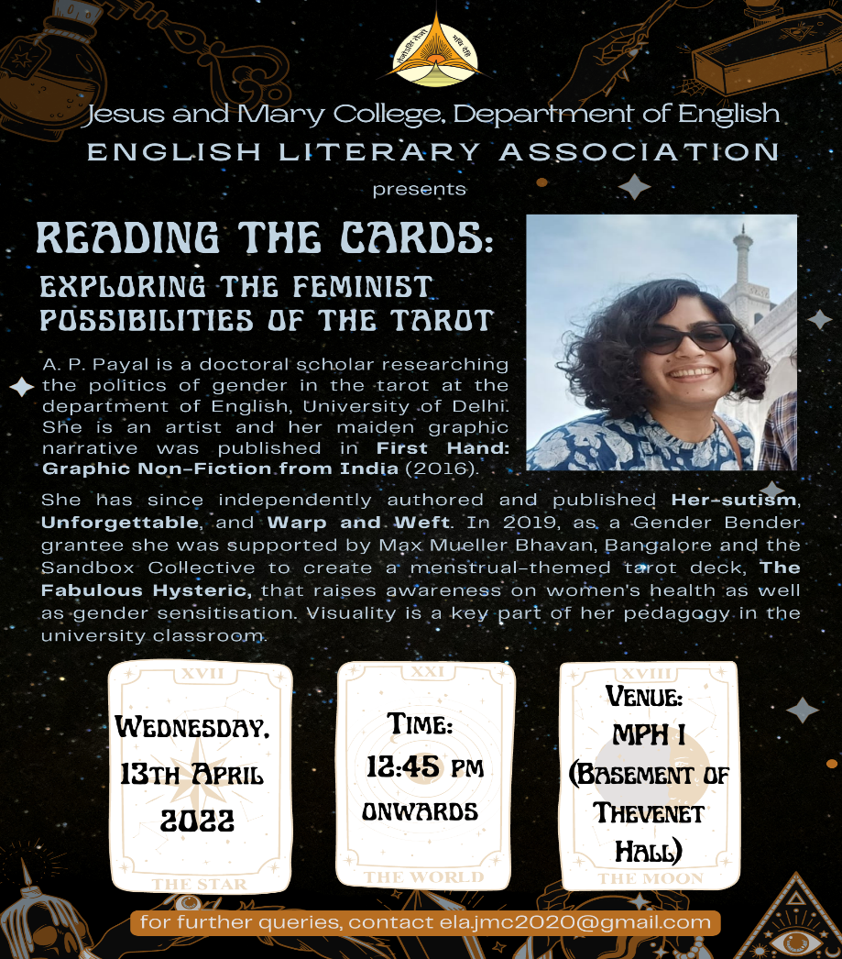
Annual Student Seminar on “The ‘Gutter’ of Literature: Graphic Narratives and Visuality”; Chairs: Dr. Susan George, Mr. Jobin Thomas, Ms. Ishita Singh, Ms. Kashish Dua (20th April 2022) (Google Meet)
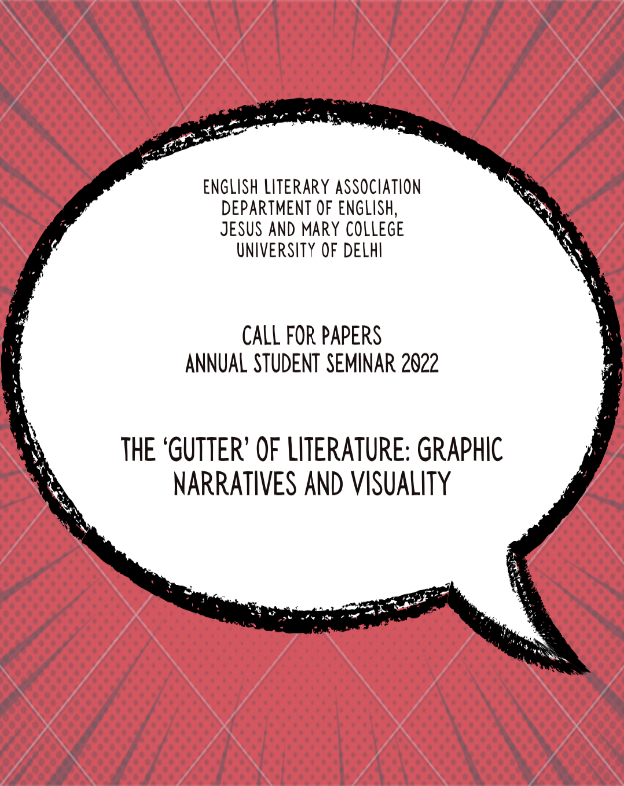
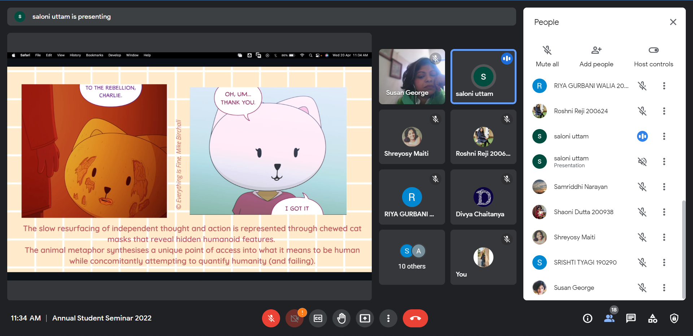

Literati Lite (Department Fundraiser) (21st April 2022)
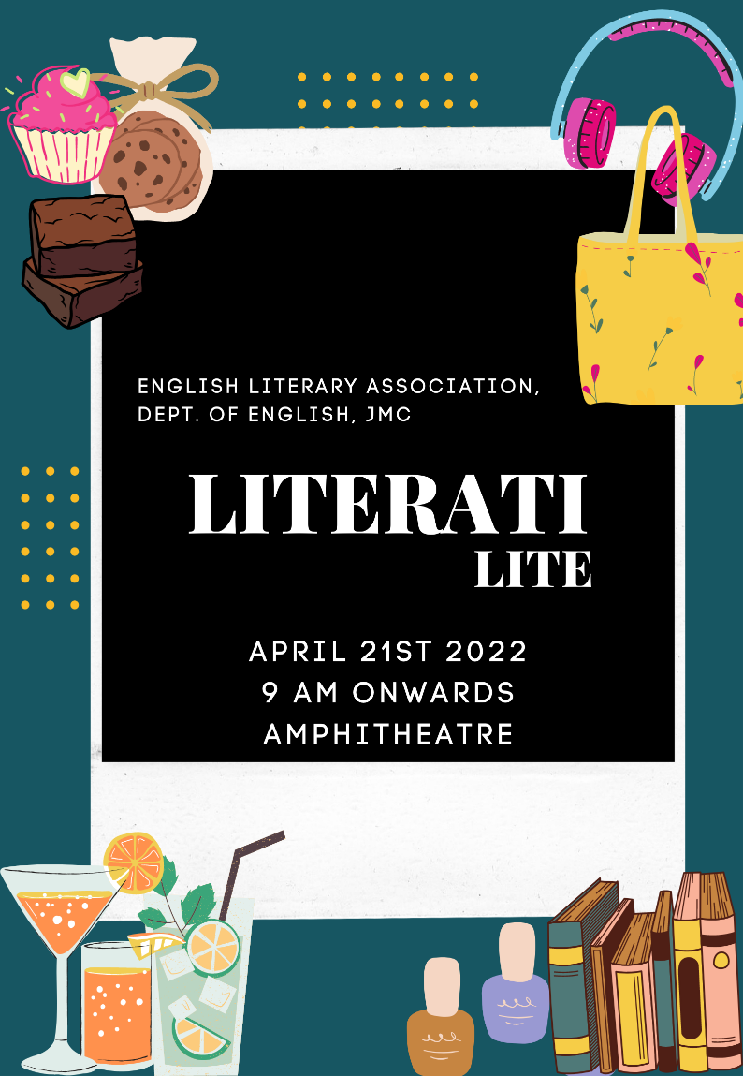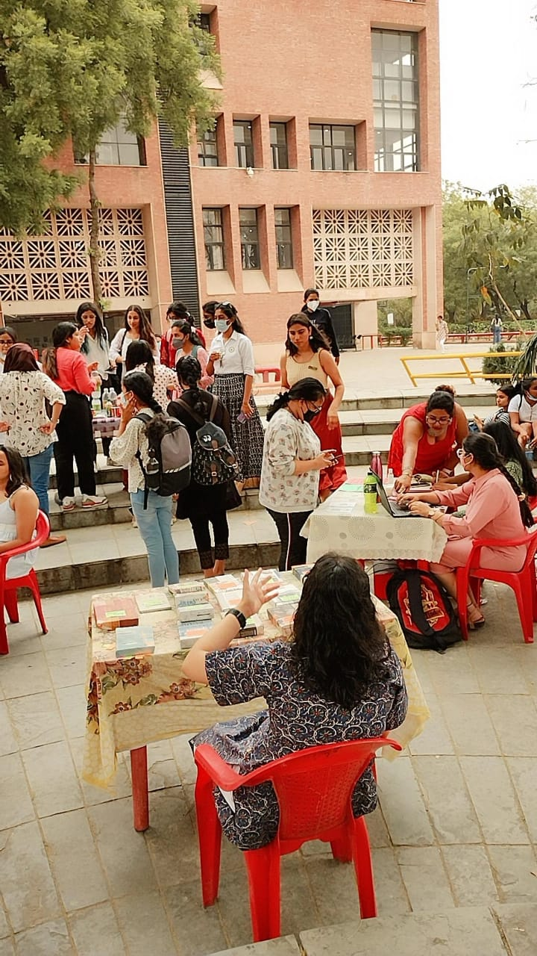
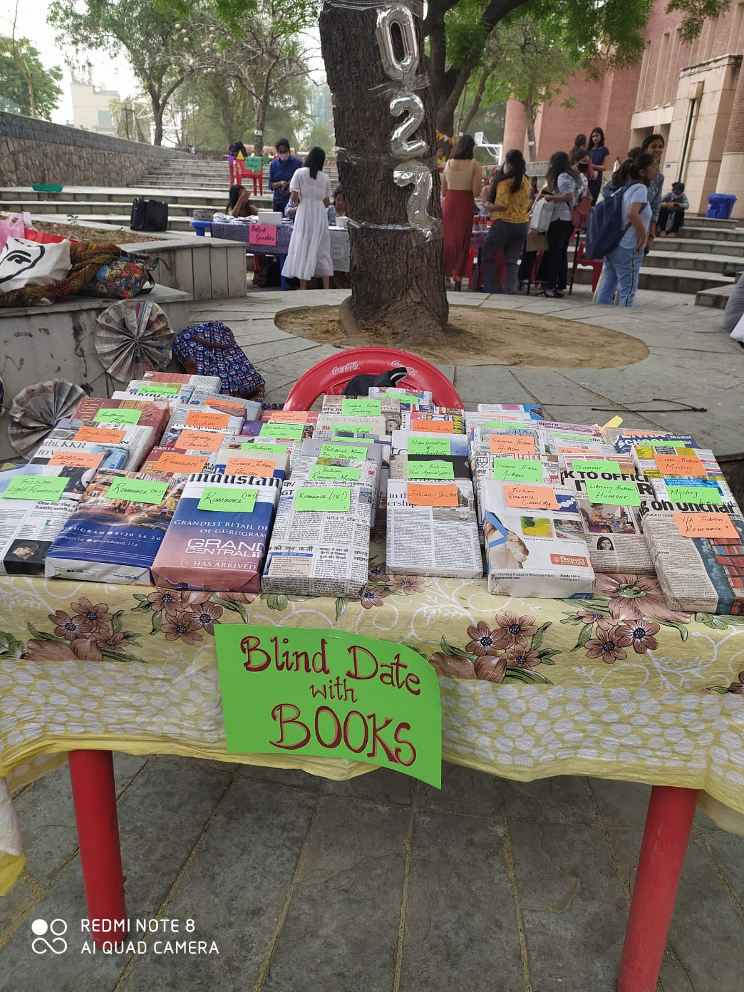
Farewell 2022 (Under the Stars, 28th April 2022)
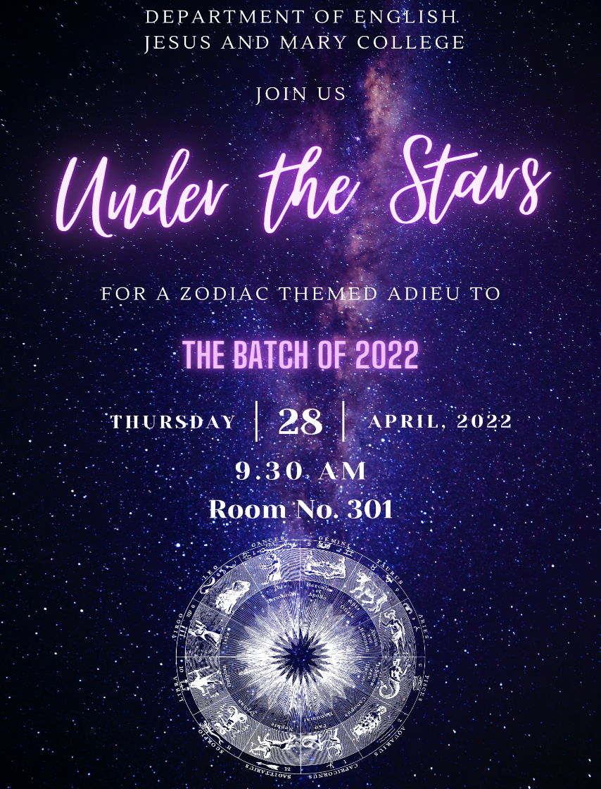

Talk by Mr. Gireesh GV on the occasion of release of Vol. II of LitScroll, the English Department Magazine, JMC (17th June 2022)
